

27
Target: ___/27 or ____ %

Year 9 HASS- Geography

40

40
Task 5 Part A: In Class Assessment Fieldwork Theory
And Skills Assessment (2.5 % weighting)
Reading Time: 5 minutes & Working Time: 35 minutes

Name: Teacher:

- What type of photograph is Source 3? (1 mark)

Aerial photograph

- Describe what is shown in Source 1. Consider cultural (built) features and natural (physical) features. (4 marks)

- Year 10 area NSHS
- Scaffolding
- Basketball ring
- Tall trees behind/beside the two story white building
- Vegetation behind basketball ring to the side of the two story building
- Brick paving
- Bitumen/asphalt
- Two story white building
- Brick building with tiled roof in the foreground
- Table and chairs
- Sunny day
- Limestone stairs and wall
- Building in progress
- Second basketball ring
- Covered drain

- Describe what is shown in Source 2. Consider cultural (built) features and/or natural (physical) features. (4 marks)

- Year 10 area NSHS
- Basketball ring
- Brick paving
- Bitumen/asphalt
- Two story white building
- Brick building with tiled roof in the foreground
- Limestone stairs and wall
- Vegetation behind basketball ring to the side of the two story building
- Cloudy day
- Second basketball ring
- Veranda – Awning – Covered area over the limestone wall paved area
- Covered drain

- Explain the change that has happened over time between Source 1 and Source 2.
(6 marks)

The Year 10 area at NSHS has changed over time:

- Source 1 has trees behind/to the side of the two story white building whereas Source 2 does not.
- Source 1 is a building site whereas Source 2 is not.
- Source 1 has table and chairs on the bitumen whereas Source 2 does not.
- Source 1 was a photograph taken on a sunny day whereas Source 2 was a photograph taken on a cloudy day.
- There is scaffolding present in Source 1 whereas Source 2 has no scaffolding.
- Source 1 does not have a veranda – Awning – a Covered area - over the limestone wall paved area whereas Source 2 does have a competed covered area.

SOURCES: Refer to the following images to answer Assessment 5A.
Please do not mark this page.
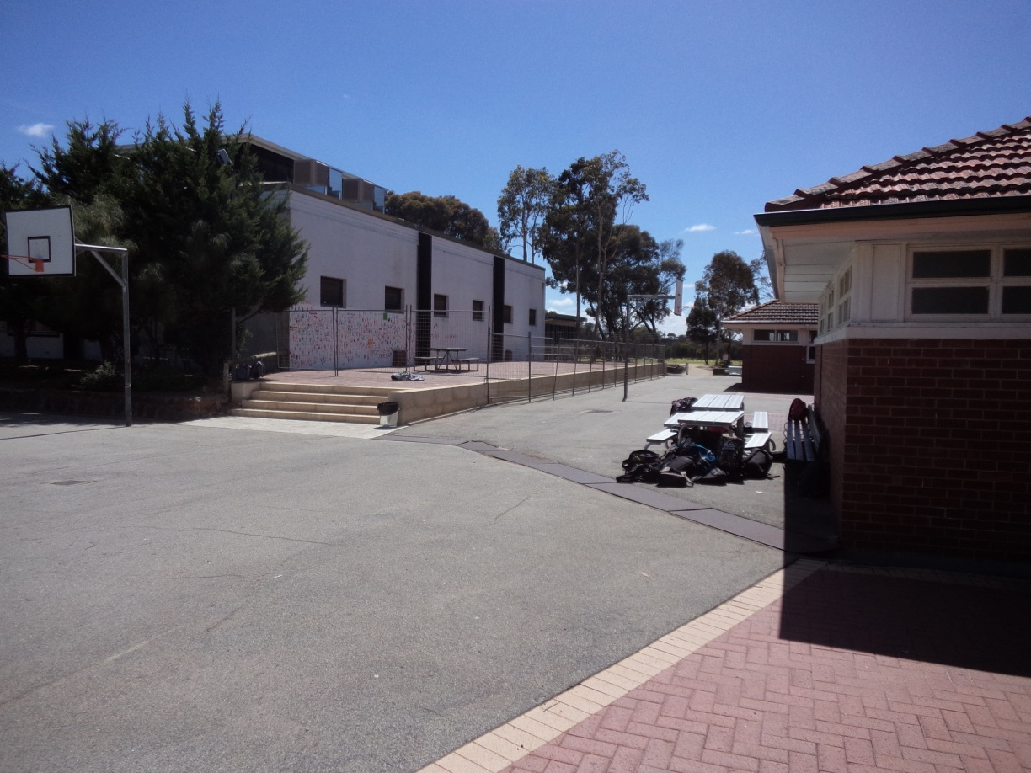
Source 1:
Around 2016

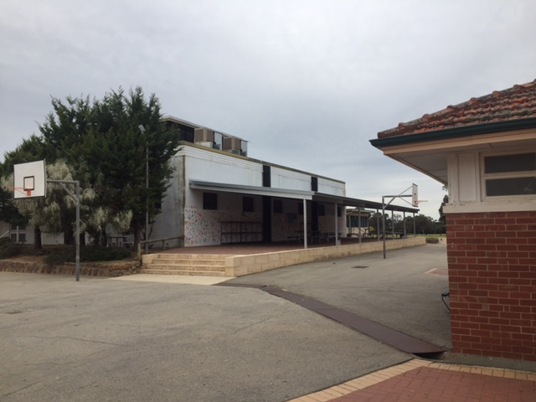

Source 2:
2017

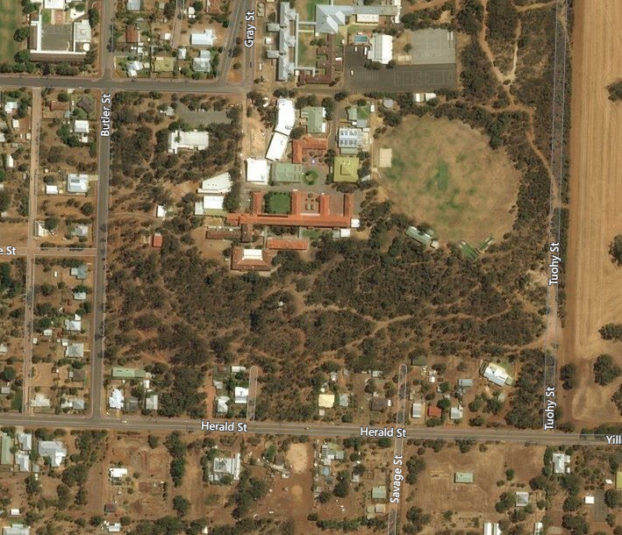
Source 3:

My Map Street View, http://mymapstreetview.com/earth/?t202id=3199&c1=GGS-MyMapST&t202kw=google%20earth&gclid=EAIaIQobChMImNfvyI2k1gIVDr69Ch0k2geYEAAYASAAEgKB5_D_BwE, retrieved on 14/9/17
Source 4:
